Roll No:241001057

Ex 6: Programs in Prolog

1. Family Relationships
Problem: Define family relations and answer grandparent queries.
% Facts parent(john, mary). parent(mary, susan). parent(john, mike).
% Rules grandparent(X, Y) :- parent(X, Z), parent(Z, Y).
OUTPUT:
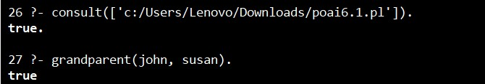

2: Animal Classification
Problem: Identify if an animal is a mammal based on features.
% Facts has_hair(tiger). gives_milk(tiger).
% Rule mammal(X) :- has_hair(X), gives_milk(X).
OUTPUT:
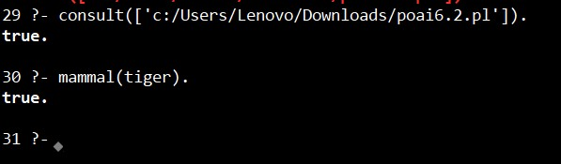

3: Simple Arithmetic Knowledge Base
Problem: Implement simple addition using PROLOG.
% Rule add(X, Y, Z) :- Z is X + Y.
OUTPUT:
